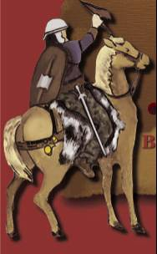
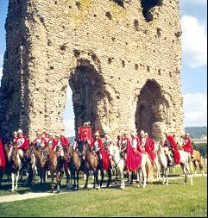
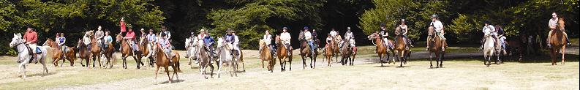

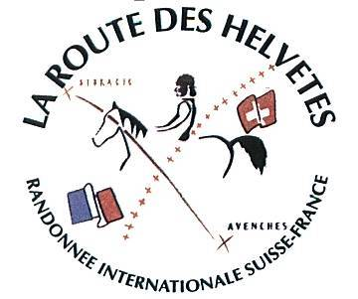
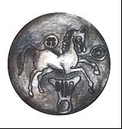

25 to 30 July 2005

Bibracte - Alésia - Autun

The Rules of the Ride

Organising committee

La Route des Helvètes | Bernard SYMZAK

With the support of:

Bibracte | Anne FLOUEST
National Forestry Commission | Jean Pierre NADALUTI
Departmental Riding Commission | Max RENAUD
The Morvan Park | Pascal RIBAUD
Montcharlon Riding Centre | Véronique DARGIER de SAINT VAULRY

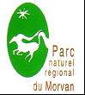








Background

The itinerary that links Alesia with Autun goes through three very important sites in our earliest history. From the Alesia Oppidum and from the beech trees covered craggy heights of Bibracte, all the way to the theatre of Augustodunum, we will pass through key moments of the history of Gaul. But we will also journey across the national parks of the Morvan and the Auxois, rich in agricultural pasture, which is very much part of our present.

Over the last 2,000 years not all has changed deep in the forests and in the neatly hedged small-holdings. The outlines of modern-day living very often spring out from the remains of Gallo-Roman villages and blend in with the shadows of an earlier Gaul.

Ten generations of oak have not erased all traces of our ancestors and signs of their passage are abundant. Landmarks accompany us the length of the ride recalling earlier centuries and monuments of bygone eras. To travel from ancient Gaul to present day France, we pass through the middle ages, the Renaissance and even echoes of the reign of the Sun King – Louis 14th. Between Alesia and Autun, after the gentle swell of the land in the Auxois and the forests of the Morvan, we penetrate into a distillation of the very essence France, we discover a history that has been re-discovered by archaeologists but is redolent with present day hospitality.

Accompanied by riders from the National Forestry Commission, we will follow the tracks of wild boar and deer, we will see historic trees and sacred springs and discover plants with medicinal properties, as well as the last traces of our predecessors.

Each evening will provide a leap back in time. Echoes of this past will be both musical as well as culinary:

After an explanation of the famous battle of Alesia, a gallo-roman meal will be served

At Saulieu, we will dance to music from the 1930’s.

At Arleuf, folk music from the Morvan will help evoke medieval logging in the Morvan, the floating of trees down river and the transport of the riches of the forest into the surrounding valleys drawn by beasts of burden.

With the help of both craftsmen and chefs, you will be convinced you have become a Gaul at the Bibracte camp.

And finally, you will become a true Roman seated in the theatre of Augustodunum.

ALESIA
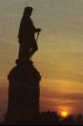
Following the path that snakes around the slopes of Mount Drouot, the mass of Mount-Auxois suddenly rears up - the site of the now disappeared Oppidum d’Alésia. This is the first panorama to confront the rider and was the very same view that presented itself to the Roman soldiers who started to occupy the surrounding plateaux. “The actual site of Alesia is at the summit of a sharp promontory. By virtue of its location, the site appears impregnable to any attack, except a blockade” (Cesar, Gallica Wars VII, 69-1). The river Ozerain is one of the waterways cited in his account. It winds through a rich and verdant valley with steep sides, so typical of the Auxois countryside.

BIBRACTE

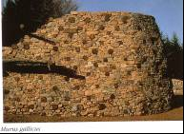
2000 years ago, the rich Eduens Gauls settled on Mount Beuvray – the only summit to strike out from the Morvan massive. This historic crossroads of early life became known as Bibracte, a fortified town surrounded by double ramparts, which sheltered its development. This economic and social capital covered 600 acres. Its fairs traded goods from the workshops of its craftsmen as well as from the whole of the Celtic and Mediterranean civilisations. Bibracte saw one of the greatest battles of the Gallic Wars: It was here that Vercingétorix united the Gauls against the Romans and that César started writing De Bello Gallico during a winter break after his victory at Alesia in 52 BC.

Autun was founded at the end of the first century BC. at the orders of the emperor Augustus. 15 Roman roads were constructed out from the town. It was surrounded by four miles of ramparts, four monumental gates (the Saint-André and Arroux gates remain completely intact), as well as a variety of buildings dedicated to the performing arts - one of these was the largest theatre in all Gaul and could contain 20,000 spectators. You can also find the Temple of Janus, a traditional Celtic sanctuary.
At the highest end of the town, Saint-Lazare cathedral is one of the most beautiful Roman churches, designed in the regional Cluny style and embellished in high gothic style. Its tympanun and capitals were sculpted in the XIIth century by Gislebertus.

AUTUN – The Temple of Janus

The Rules of the Ride:

Alésia-Bibracte-Autun

1 This expedition is open to up to 100 riders or group leaders. Horse drawn vehicles must be light all-surface conveyances.

Minors must be accompanied by an adult. Notions of ‘competition’ or racing, are totally foreign to the spirit of this ride, which is anchored in respect for our horses and of Burgundy’s environment, as well as of the lifestyles and culture of all participants. The pursuit of friendship between the wide range of horsemen and women on the ride is central to the character of the ride.

2 The Bibracte –Alésia ride is not particularly demanding. 15- 20 miles are covered each day. Accommodation is however quite simple – our ancestors from ancient Gaul would find the conditions relatively familiar – we sleep in dormitories; washing and toilet facilities can be fairly simple. Should participants wish to reserve their own accommodation (no price reduction is given should you choose to do this), please state this on the booking form. A list of hotels will be provided, but be aware that the hotel room capacity in the region is very limited and reservations need to be made soonest.

3 Costs of organisation, accommodation and subsistence are covered by:
- The fees paid by each participant
- Contributions from sponsors – both financial and material
- Local communities

4 The organisers will transport the luggage of participants and groups without a support vehicle

5. Up-to-date vaccination certificates must be brought for all horses confirming immunisation against rabies, horse fever and tetanus.

6. Valid insurance cover is mandatory for all participants covering public liability risks, as well as fire and damage caused by participants, their horse(s), and/or vehicles. If you have a valid ‘Licence’ from the French Riding Federation, you are already covered.

7. The itinerary will be indicated by markers. Participants will receive at the start of the ride a 1:50,000 map with both the itinerary and picnic locations highlighted. Alternatively, they may wish to purchase the relevant 1:25,000 map which covers the itinerary - From the Institut National Geographique, Serie Bleue, the relevant maps no:s are: 2922 O, 2922 E, 2923 O, 2825 E TOP 25 N°: 2823 ET, 2825 OT.

8. The price of the ride is 250€ per rider with their own horse.
This price includes:
- Accommodation: Camp beds (sheets and blankets are NOT provided), from Monday evening July 25 to Saturday morning July 30 – a total of five nights.
- Full board from lunchtime on Monday 25th to breakfast on July 30th. This includes:
  - Evening meals at times to be indicated
  - Breakfast between 07:30 and 08:30
  - Picnics at midday
  - Drinks are NOT INCLUDED, but will be available for purchase from a mobile bar.
- Food for the horses (8 kilos of hay and 6 kilos of DESTRIER aliment) per day/per horse from July 25 to the morning of July 30
- Information concerning access to medical and veterinary services, as well as a blacksmith will be provided. Participants WILL BE CHARGED for all such services and payment must be made on the spot; the price is to be negotiated between the participant and the relevant vendor.
- Transport of luggage from each between accommodation locations
- Evening entertainment, but NOT drinks

At night horses will be secured with ropes. Drinking water for the horses is also provided. Horses that kick and ALL stallions MUST have a red ribbon attached to their tails.

At the end of the ride on Saturday morning, July 30 2005, drivers of vehicles transporting horses will be accompanied back to the start of the ride.

9. To make a reservation, fill in the attached form and send it to:

La Route des Helvètes
Montcharlon
58 170 CHIDDES
Tel/Fax : 00 33 3 86 30 42 78

For a reservation to be valid, it must be accompanied by a cheque covering the deposit of 100€ per rider and made payable to “La Route des Helvètes”.

The balance - 150€ per rider - must be received by the organisers by 31st May 2005 at the very latest.
Deposits will not be refunded for any cancellation after the 31st March.

50% of the deposit paid (50€ per rider) will be reimbursed if a cancellation is made before March 31st. No reimbursement whatsoever will be made of a rider drops out during the ride.

10. Dogs are not allowed on the Bibracte-Alésia ride

